8.1.1 Write a Python program to perform the multiplication of two square matrices. The program should take two matrices as input and output their product.

Algorithm
1.Start
2.Input the order n of the square matrices.
3.Input elements of Matrix A and Matrix B.
4.Create a result matrix R of size n × n and initialize all elements to 0.
5.Initialize loop variable i from 0 to n−1.
6.Inside that, initialize loop variable j from 0 to n−1.
7.Inside that, initialize loop variable k from 0 to n−1.
8.Perform multiplication and addition: If inside loops → R[i][j] = R[i][j] + A[i][k] × B[k][j]
9.Repeat until all loops finish.
10.Print the result matrix R.
11.Stop.
Flowchart
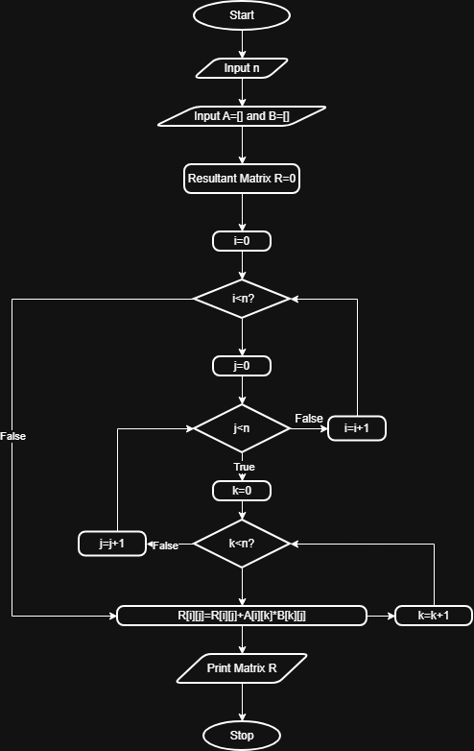
CODE
